Mandatory Experiment 4.2a

A hydrochloric acid/sodium hydroxide titration and the use of this titration in making the salt sodium chloride

Student Material

Theory

The concentration of a basic (alkaline) solution may be found by titration with a known concentration of acid solution. The end-point is found by using methyl orange as the acid-base indicator. At the end-point – when neutralisation just occurs – the indicator changes colour from yellow to peach/pink.

The experiment can then be repeated without the indicator, and the neutral solution obtained evaporated to give the salt.

Using hydrochloric acid (HCl) and sodium hydroxide (NaOH), the product of the reaction is sodium chloride (common salt) and water

HCl + NaOH → NaCl + H₂O

Chemicals and Apparatus

Standard 0.1 M hydrochloric acid solution
Sodium hydroxide solution of unknown concentration _{i}
Methyl orange indicator 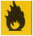
Deionised water

Burette (50 cm³)
Retort stand
Boss-head
Clamp
Filter funnel
Conical flask (250 cm³)
Pipette (25 cm³)
Pipette filler
Wash bottle
White card
White tile
Beakers (250 cm³)
Safety glasses

Procedure

NB: Wear your safety glasses.

- To find the end-point accurately

- Rinse the burette, pipette and conical flask respectively with deionised water.

- Rinse the burette with hydrochloric acid solution, and rinse the pipette with sodium hydroxide solution.

- Using the pipette, transfer 25 cm³ of the unknown sodium hydroxide solution into the clean conical flask. Add 5 drops of methyl orange indicator.

- Fill the burette to the 0 cm³ mark with hydrochloric acid solution.

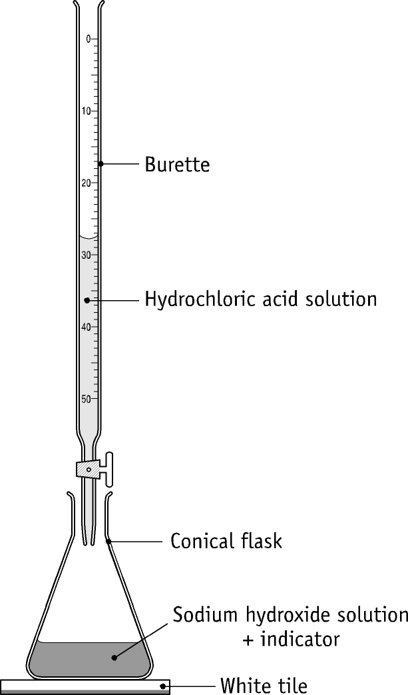

- Carry out one rough and two accurate titrations.

- Calculate the concentration of the sodium hydroxide solution.

- To obtain a sample of salt

- To 25 cm³ of the sodium hydroxide solution in a beaker, add just enough hydrochloric acid to exactly neutralise it. The indicator should not be added.

- Gently heat the solution until all the water has evaporated to dryness. A sample of sodium chloride will remain in the beaker.

Table of Results

Rough titre =
Second titre =
Third titre =
Average of accurate titres =

Volume of sodium hydroxide solution used in each titration =
Concentration of hydrochloric acid solution =
Concentration of sodium hydroxide solution =

Questions relating to the experiment

1. Describe, briefly, the washing/rinsing procedure for the apparatus before starting the
titration.

2. Mention two other precautions that should be taken to ensure accuracy when using a
pipette.

3. Mention three operations, which should be carried out during the titration to ensure
an accurate titre.

4. Suggest another suitable indicator for this reaction. How would you test to see
whether your suggestion would work?

5. Why is it undesirable to put the sodium hydroxide solution into the burette rather
than in the conical flask?

6 Can you suggest a means of neutralising a (a) HCl and (b) HNO₃ acidic effluent
from a manufacturing process to enable it to be disposed of safely? Write the
chemical equations for the appropriate reactions.

Teacher Material

- A fuller description of titration procedure is to be found in the Student Material relating to Mandatory Experiment 4.2.

- Methyl red solution may also be used as the indicator in this titration. In this case, the indicator changes colour from yellow to pink at the endpoint.

- Phenolphthalein solution may also be used as the indicator in this titration. In this case, the indicator changes colour from pink to colourless at the endpoint. This colour change is as clear-cut as with methyl red; however, the endpoint is not detected as accurately with phenolphthalein as with methyl red.

- If 1 M solutions of acid and base are used, methyl orange indicator changes colour from yellow to pink at the endpoint.

Care is required when evaporating the sodium chloride solution to dryness. Gentle heating is essential near the end of this procedure.

Preparation of reagents

0.1 M hydrochloric acid solution:
Use ampoules of 1 M HCl and dilute 10 cm³ to 100 cm³ with deionised water.
Laboratory grade HCl is not sufficiently pure to be used as a primary standard; however dilute HCl can be titrated against sodium carbonate (see mandatory experiment 4.2).

Sodium hydroxide solution: approximately 0.1 M sodium hydroxide solution is made by weighing out about 4 g NaOH, and adding this to about 50 cm³ of deionised water to dissolve it. Cool the solution if necessary. Make up to 1 litre in a volumetric flask.

Quantities per working group

150 cm³ 0.1 M HCl
150 cm³ sodium hydroxide solution
5 cm³ methyl orange solution

Safety considerations

- Safety glasses must be worn.
- A fume cupboard should be used when making up the hydrochloric acid solution.

Chemical hazard notes

Solid sodium hydroxide 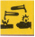 is corrosive, and can cause severe burns to eyes and skin. Always wear eye protection.

Concentrated hydrochloric acid is very corrosive to eyes and skin, and its vapour is very irritating to lungs.

Solutions of methyl orange usually contain 50% ethanol and are flammable.

Disposal of wastes

Dilute with water, and flush to foul water drain.

Specimen results

Rough titre = 24.2 cm³
Second titre = 24.1 cm³
Third titre = 24.2 cm³
Average of accurate titres = 24.15 cm³

Volume of sodium hydroxide solution used in each titration = 25.0 cm³
Concentration of hydrochloric acid solution = 0.1 M

Specimen Calculations

Formula method

V_{A} x M_{A} x n_{B} = V_{B} x M_{B} x n_{A}

24.15 x 0.1 x 1 = 25.0 x M_{B} x 1

M_{B} = 24.15 x 0.1 x 1 / (25.0 x 1) M

= 0.0966 M
Concentration of sodium hydroxide solution = 0.097 M

Solutions to student questions

1. Describe, briefly, the washing/rinsing procedure for the apparatus before starting the
titration.

Rinse the burette, pipette and conical flask respectively with deionised water. Rinse
the burette with hydrochloric acid solution, and rinse the pipette with sodium
hydroxide solution.

2. Mention two other precautions that should be taken to ensure accuracy when using a
pipette.

Make sure that it is filled exactly to the mark. Allow it to release its contents freely, and then touch it to the inside of the conical flask for a few seconds.

3. Mention three operations that should be carried out during the titration to ensure
an accurate titre.

Swirl the contents of the conical flask after each addition of acid to the conical flask.
Using a wash bottle, wash down with deionised water any solution adhering to the
sides of the conical flask. Take all burette readings at eye level.

4. Suggest another suitable indicator for this reaction. How would you test to see
whether your suggestion would work?

Methyl red (or phenolphthalein).
Repeat the experiment to see if the same result was obtained.

5. Why is it undesirable to put sodium hydroxide solution into the burette rather than
in the conical flask?

If the burette is not washed out very thoroughly after use, sodium hydroxide may
crystallise in the Teflon tap causing blocking of the burette nozzle, or, at best,
changing the concentration of the delivered solution.(If a burette with a glass tap
is being used, the tap is likely to get stuck.)

6. Can you suggest a means of neutralising a (a) HCl and (b) HNO₃ acidic effluent
from a manufacturing process to enable it to be disposed of safely? Write the
chemical equations for the appropriate reactions.

Neutralise with NaOH solution.
HCl + NaOH → NaCl + H₂O
HNO₃ + NaOH → NaNO₃ + H₂O

